***LINKEDIN***

***SKILLSHARE***

***FACEBOOK***

***INSTAGRAM***

***SNAPCHAT***

***TIKTOK***

***YOUTUBE***

***PERSONAL WEBSITE***

**IBM COGNITIVE CLASS**

***EVENTBRITE***

***RESEARCHGATE***

***IBM CREDENTIALS AND BADGES***

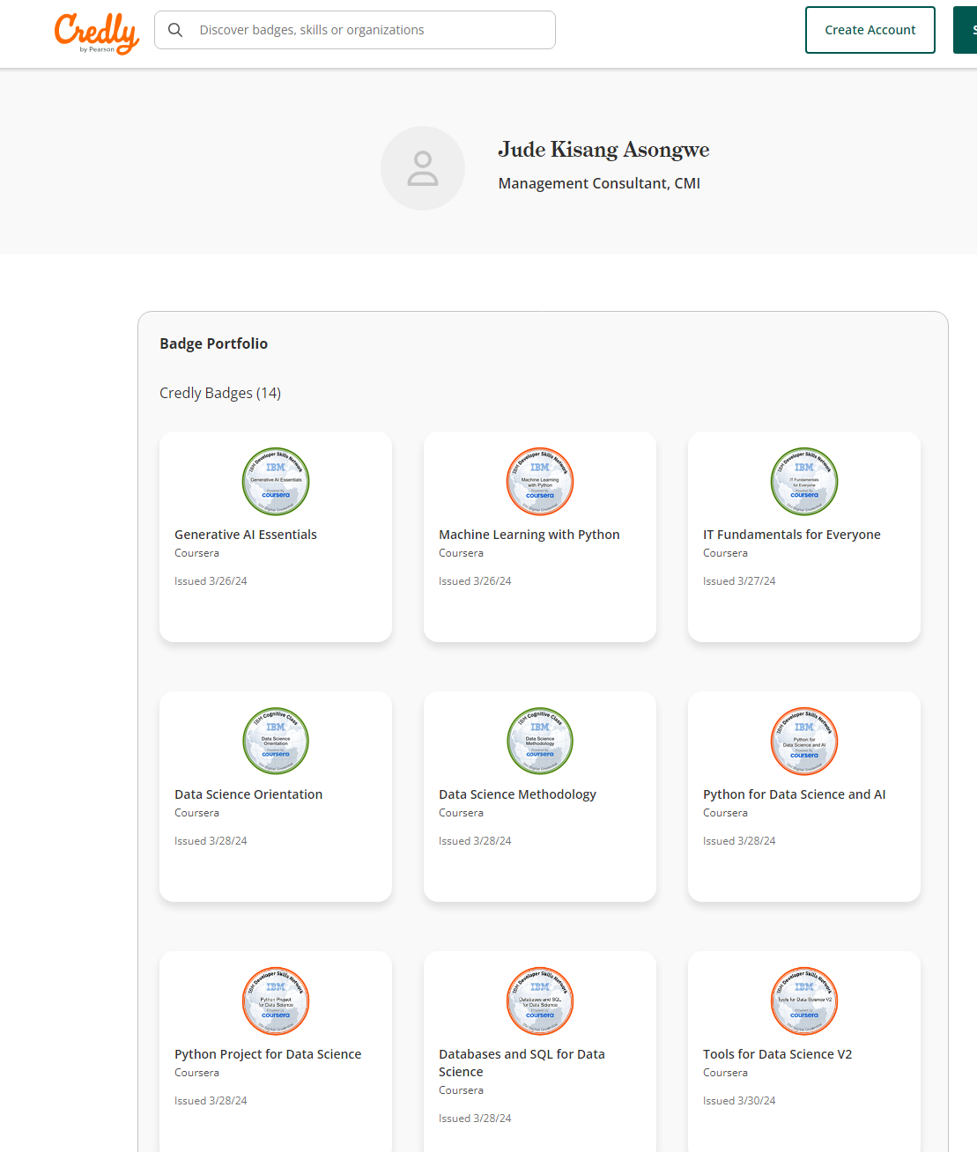

***GITHUB***

***COURSERA***

***ACADEMIA***

***TWITTER***